VCL Rich Edit Control

Word® Inspired Rich Text Editor

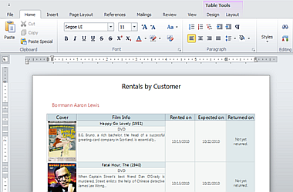

The [DevExpress VCL Rich Edit Control](https://www.devexpress.com/Products/VCL/) allows you to introduce advanced text editing capabilities into your next application with ease. The Rich Edit Control provides comprehensive text formatting options, mail-merge and a rich collection of end-user options so you can deliver your best, without limits or compromise.

To the Top